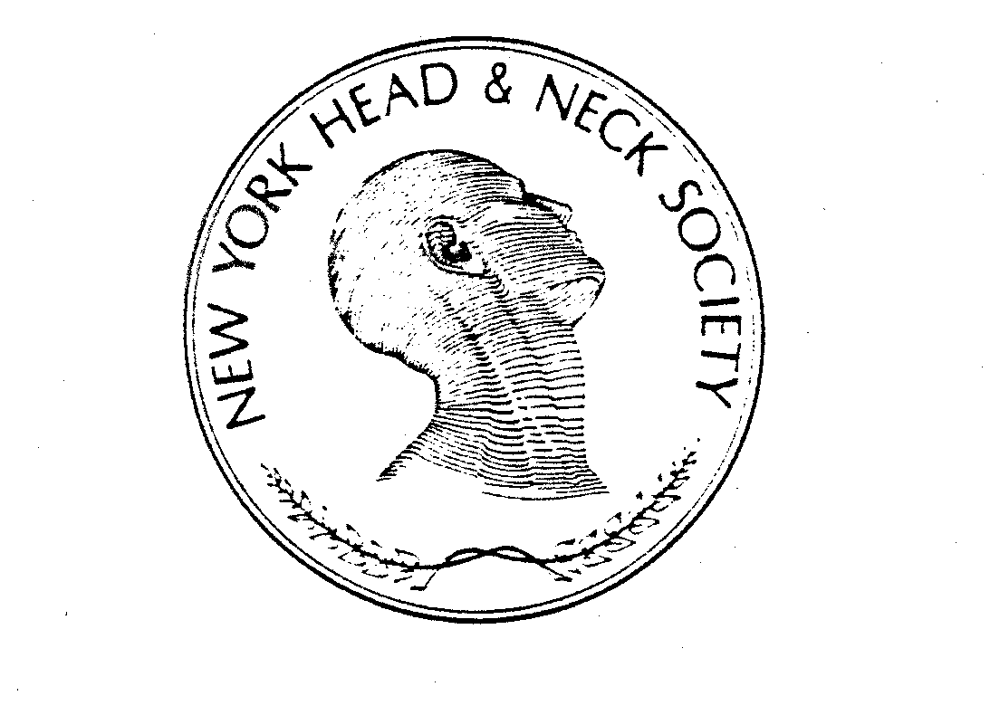

NEW YORK HEAD AND NECK SOCIETY

Allied Health Professional Membership Application

NAME: ____________________________________________________________________
^{Last} ^{First}

ADDRESS: _________________________________________________________________
_________________________________________________________________

TELEPHONE: _____________________________ FAX: ________________________
EMAIL: ____________________________________________________________________

Hospital Affiliations: __________________________________________________________
___________________________________________________________________________
___________________________________________________________________________
___________________________________________________________________________

Medical School Appointments:

___________________________________________________________________________
__________________________________________________________________________
Licensed in the State(s) of: _______________________ License #: __________________
License #: __________________
Specialty: ___________________________________________________________________
POST GRADUATE EDUCATION: (Please specify internship, residency & any special training in Head and Neck surgery or related fields.)

Institution: _______________________________________ Year: _______________
Institution: _______________________________________ Year: _______________
Institution: _______________________________________ Year: _______________
Institution: _______________________________________ Year: _______________

Board Certification or Equivalent:

Name: ___________________________________________ Date: _______________

SOCIETY MEMBERSHIPS
________________________________________________________________________
________________________________________________________________________
________________________________________________________________________

Estimate the time devoted to the field of head and neck surgery or its equivalent in related fields:
________________________________________________________________________
________________________________________________________________________
________________________________________________________________________
Names of sponsor and seconder who are members of this society:

SPONSOR: ________________________________________________________________________
SECONDER: _____________________________________________________________________

PLEASE INCLUDE A COPY OF YOUR CURRICULUM VITAE AND BIBLIOGRAPHY

_______ ______________________________________________________
Date Signature of the Applicant

E-Mail Membership Application to: Natalya Chernichenko, M.D.
(Natalya.chernichenko@downstate.edu)
Steven Savona, M.D.
(ssavona@nshs.edu)

Completed applications, sponsor’s and seconder’s letters must be received no later than February 1 to be considered for action this year.

